

# Calculating Family Expenses using ServiceNow

**Team ID: NM2025TMID20271**

**Team Members:**

**Team Leader:** SANJAY S **Team Member 1:** DEVARAJ K **Team Member 2:** SATISH H

**Team Member 3:** MALLELA MAHENDRA

**Category:** ServiceNow System Administrator

# Problem Statement:

Managing and tracking family expenses manually often leads to inefficiency, errors, and lack of visibility into spending habits. Families require a structured and automated way to categorize, monitor, and report expenses to achieve better financial planning and decision-making.



# Objective:

To design and implement an automated family expense calculation system using ServiceNow that supports expense categorization, budget setting, real-time tracking, and reporting.

# Skills Required:

IoT Open Hardware Platforms Data Structures

# Project Description:

This project aims to build a comprehensive expense calculation system leveraging the ServiceNow platform. The system will allow users to:

Track and manage family expenses efficiently. Categorize expenses into meaningful groups. Set and monitor budgets with real-time alerts.

 Generate detailed reports and insights for better decision-making.

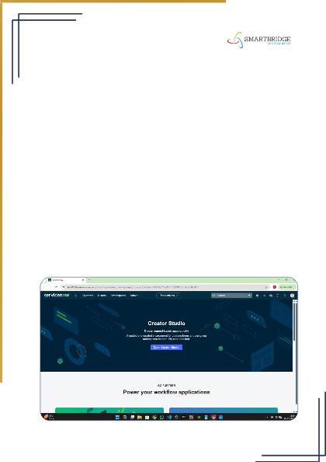**TASK INITIATION**

**Milestone 1 :** Setting up ServiceNow Instance

**Activity 1:** Create and Access Instance

1. **Open** [**ServiceNow Developer Site**](https://developer.servicenow.com/)**.**
2. **Sign up for a developer account and log in.**
3. **Navigate to Personal Developer Instance.**
4. **Click Request Instance and fill the required details.**
5. **Submit the request.**
6. **Once approved, check your email for instance details.**
7. **Log in using the provided credentials.**
8. **Verify that you can successfully access and navigate the instance.**

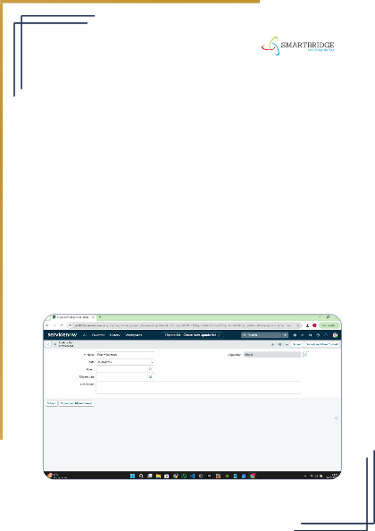

**Milestone 2 :** Create Local Update Set

**Activity 1:** Create Update Set

1. **Open ServiceNow.**
2. **Go to All >> in the filter, search for Local Update Set.**
3. **Click on New.**
4. **Enter the details as:**
5. **Name: Family Expenses**
6. **Click on Submit.**
7. **Select Make Current to activate the update set.**

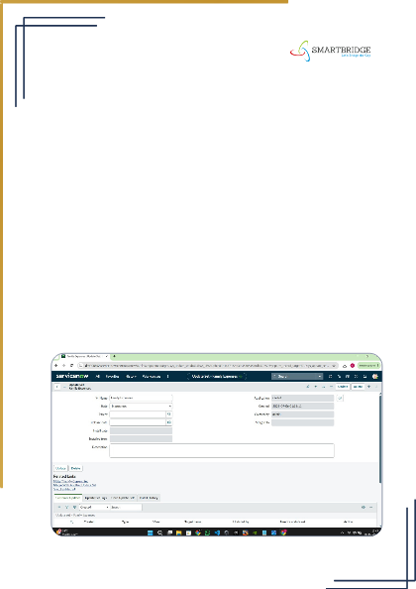

**Milestone 3:** Creation of New Update Set

**Activity 1:** Create Local Update Set

1. **Open ServiceNow.**
2. **Go to All >> in the filter, search for Local Update Set.**
3. **Click on New.**
4. **Enter the following details:**
5. **Name: Family Expenses**
6. **Click on Submit.**
7. **Select Make Current to activate the update set.**

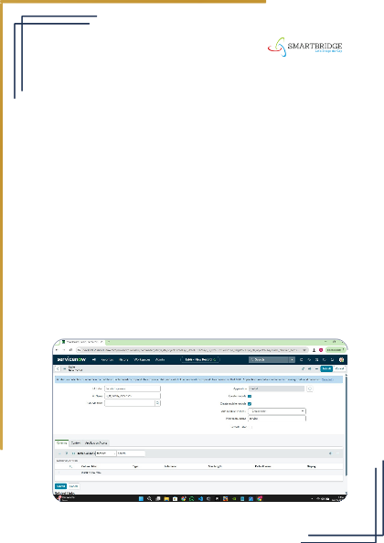

**Milestone 4:** Creation of Family Expenses Table

**Activity 1:** Create New Table

1. **Open ServiceNow.**
2. **Go to All >> in the filter, search for Tables.**
3. **Click on New.**
4. **Enter the following details:**
5. **Label: Family Expenses**
6. **Name: (Auto-Populated)**
7. **New Menu Name: Family Expenditure**
8. **Go to the Header, right-click, and then click on Save.**

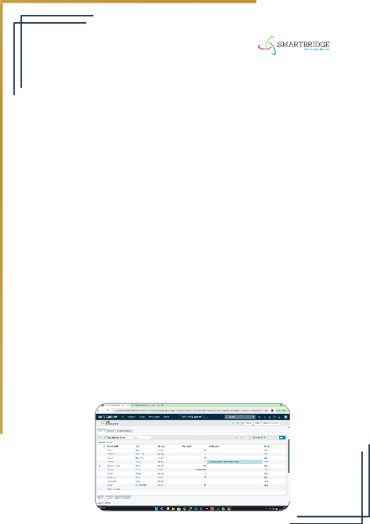**Milestone 5 :** Creation of Columns (Fields)

**Activity 2:** Add Columns to Family Expenses Table

1. **Open the Family Expenses Table in ServiceNow.**
2. **Near Columns, double-click on Insert a new row.**
3. **Column Label: Number**
4. **Type: String**
5. **Double-click on Insert a new row again.**
6. **Column Label: Date**
7. **Type: Date**
8. **Double-click on Insert a new row again.**
9. **Column Label: Amount**
10. **Type: Integer**
11. **Double-click on Insert a new row again.**
12. **Column Label: Expense Details**
13. **Type: String**
14. **Max Length: 800**
15. **Go to the Header, right-click, and then click on Save.**

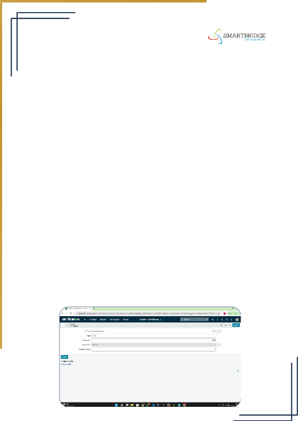**Milestone 6 :** Making Number Field an Auto-Number

**Activity 3:** Configure Auto-Number for Number Field

* 1. **Activity 1: Configure Auto-Number for Number Field**
  2. **Open the Family Expenses Table in ServiceNow.**
  3. **Double-click on the Number field/column.**
  4. **Scroll down and click on Advanced View.**
  5. **In Default Value:**
  6. **Check the box for Use dynamic default.**
  7. **Set Dynamic default value to Get Next Padded Number.**
  8. **Click on Update.**
  9. **Activity 2: Configure Number Maintenance**
  10. **Go to All >> in the filter, search for Number Maintenance.**
  11. **Select Number Maintenance.**
  12. **Click on New.**
  13. **Enter the following details:**
  14. **Table: Family Expenses**
  15. **Prefix: MFE**
  16. **Click on Submit.**

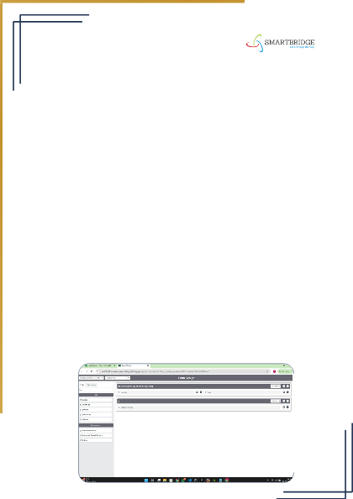**Milestone 7:** Configure the Form

**Activity 4:** Customize Family Expenses Form

1. **Go to All >> in the filter, search for Family Expenses.**
2. **Open Family Expenses.**
3. **Click on New to open a blank record form.**
4. **Go to the Header, right-click, then click on Configure >> select Form Design.**
5. **Use Drag & Drop to customize the form layout as per**

**requirements.**

1. **Activity 2: Apply Field Properties**
2. **For the Number field, click on the gear icon and set it as Read-Only.**
3. **For the Date field, click on the gear icon and set it as**

**Mandatory.**

1. **For the Amount field, click on the gear icon and set it as Mandatory.**
2. **Click on Save to apply the changes.**

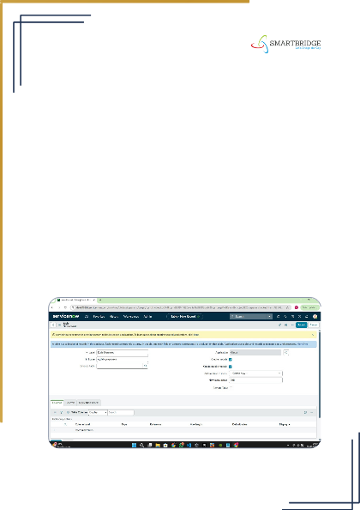**Milestone 8:** Creation of Daily Expenses Table

**Activity 1:** Create New Table for Daily Expenses

* 1. **Open ServiceNow.**
  2. **Go to All >> in the filter, search for Tables.**
  3. **Click on New.**
  4. **Enter the following details:**
  5. **Label: Daily Expenses**
  6. **Name: (Auto-Populated)**
  7. **Add Module to Menu: Family Expenditure**
  8. **Go to the Header, right-click, and then click on Save.**

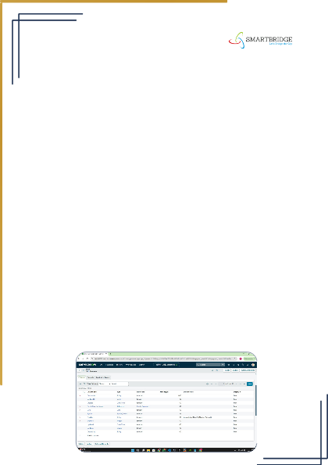**Milestone 9 :** Creation of Columns (Fields) for Daily Expenses Table

**Activity 2:** Add Columns to Daily Expenses Table

* + 1. **Open the Daily Expenses Table in ServiceNow.**
    2. **Near Columns, double-click on Insert a new row.**
    3. **Column Label: Number**
    4. **Type: String**
    5. **Double-click on Insert a new row again.**
    6. **Column Label: Date**
    7. **Type: Date**
    8. **Double-click on Insert a new row again.**
    9. **Column Label: Expense**
    10. **Type: Integer**
    11. **Double-click on Insert a new row again.**
    12. **Column Label: Family Member Name**
    13. **Type: Reference**
    14. **Max Length: 800**
    15. **Double-click on Insert a new row again.**
    16. **Column Label: Comments**
    17. **Type: String**
    18. **Max Length: 800**
    19. **Go to the Header, right-click, and then click on Save.**

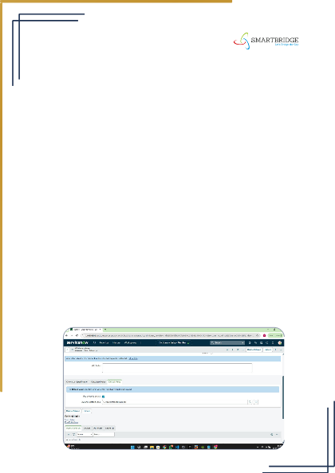**Milestone 10 :** Making Number Field an Auto-Number

**Activity 3:** Configure Auto-Number for Number Field

1. **Open the Daily Expenses Table (or Family Expenses Table if configuring there) in ServiceNow.**
2. **Double-click on the Number field/column.**
3. **Scroll down and switch to Advanced View.**
4. **In Default Value:**
5. **Check the box Use dynamic default.**
6. **Set Dynamic default value to Get Next Padded Number.**
7. **Click on Update.**
8. **Activity 2: Configure Number Maintenance**
9. **Go to All >> in the filter, search for Number Maintenance.**
10. **Select Number Maintenance.**
11. **Click on New.**
12. **Enter the following details:**
13. **Table: Family Expenses**
14. **Prefix: MFE**
15. **Click on Submit.**

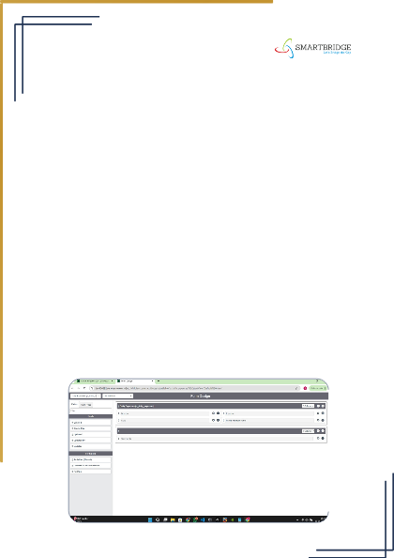**Milestone 11:** Configure the Form for Daily Expenses

**Activity 4:** Customize Daily Expenses Form

1. **Go to All >> in the filter, search for Daily Expenses.**
2. **Open Daily Expenses.**
3. **Click on New to open a blank record form.**
4. **Go to the Header, right-click, then click on Configure >> select Form Design.**
5. **Use Drag & Drop to customize the form layout as per**

**requirements.**

1. **Activity 2: Apply Field Properties**
2. **For the Number field, click on the gear icon and set it as Read-Only.**
3. **For the Date field, click on the gear icon and set it as**

**Mandatory.**

1. **For the Family Member Name field, click on the gear icon and set it as Mandatory.**
2. **Click on Save to apply the changes.**

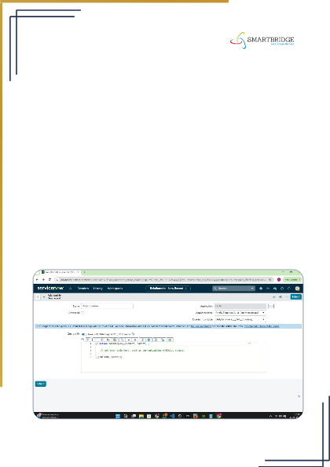

**Milestone 12 :** Creation of Relationship between Family Expenses and Daily Expenses Tables

**Activity 1:** Define Relationship

* 1. **Go to All >> in the filter, search for Relationships.**
  2. **Open Relationships.**
  3. **Click on New.**
  4. **Enter the following details:**
  5. **Name: Daily Expenses**
  6. **Applies to Table: Family Expenses**
  7. **Related List (Daily Expenses): Daily Expenses**
  8. **Click on Save to establish the relationship.**

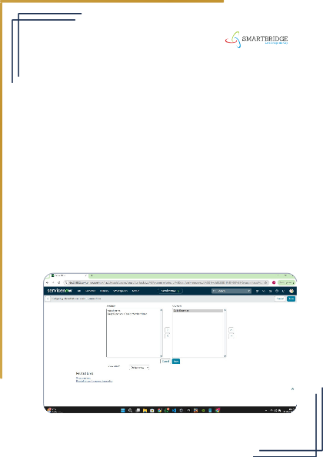

**Milestone 13 :** Configuring Related List on Family Expenses

**Activity 1:** Add Daily Expenses as Related List

1. **Go to All >> in the filter, search for Family Expenses.**
2. **Open Family Expenses.**
3. **Click on New to open a blank record form.**
4. **Go to the Header, right-click, then click on Configure >> select Related Lists.**
5. **Add Daily Expenses to the selected area.**
6. **Click on Save to apply the configuration.**

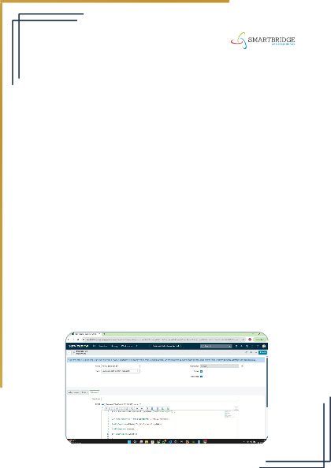

**Milestone 14 :** Creation of Business Rules

**Activity 1:** Define Business Rule for Family Expenses

* 1. **Go to All >> in the filter, search for Business Rules.**
  2. **Under System Definition, select Business Rules.**
  3. **Click on New.**
  4. **Enter the following details:**
  5. **Name: Family Expenses BR**
  6. **Table: Daily Expenses**
  7. **Check Advanced.**
  8. **Under When to run, check both Insert and Update.**
  9. **Activity 2: Add Script in Advanced Section**
  10. **Paste the script:**
  11. **Activity 3: Save the Business Rule**
  12. **Go to the Header, right-click, and then click on Save.**

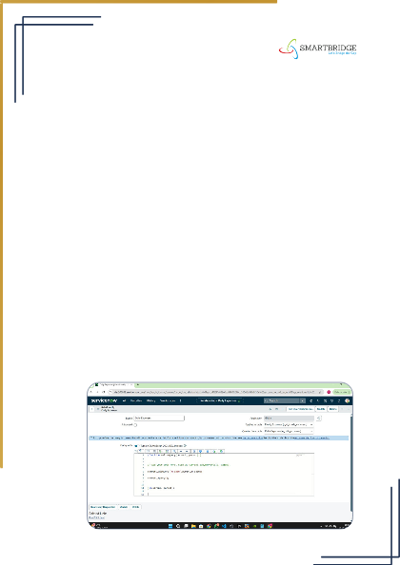

**Milestone 15 :** Configure the Relationship

**Activity 1:** Define Business Rule for Family Expenses

1. **Activity 1: Refine Daily Expenses Relationship**
2. **Go to All >> in the filter, search for Relationships.**
3. **Open Relationships.**
4. **Select the Daily Expenses Relationship.**
5. **Set Applies to Table as Family Expenses.**
6. **In Query with, add the following script:**

**(function refineQuery(current, parent) {**

**// Add your code here, such as current.addQuery(field,value); current.addQuery('u_date', parent.u_date); current.query();})(current, parent)**

1. **Click on Update to save the configuration.**



# Conclusion:

The “Calculating Family Expenses using ServiceNow” project successfully demonstrates how a robust digital platform can simplify financial management for families. By leveraging ServiceNow’s capabilities, the system provides an intuitive, scalable, and real-time solution for tracking and managing expenses. The integration of features such as expense categorization, budget setting, and detailed reporting empowers users to gain insights into their spending patterns and make informed financial decisions. This project not only enhances financial transparency within the family but also encourages disciplined budgeting and improved financial well- being. Ultimately, it highlights the potential of combining modern technology with practical financial management to create a meaningful impact on everyday life.